**Resource list and costs**

**Budget = 150,000**

**Total salary cost = 18,507**

**Total cost for materials and labour = 84,771**

**Overall total = 84,771 + 18,507 = 103,318**

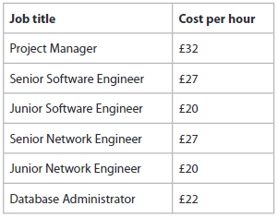

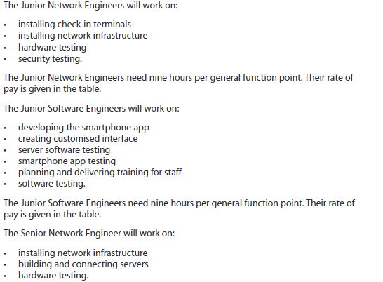

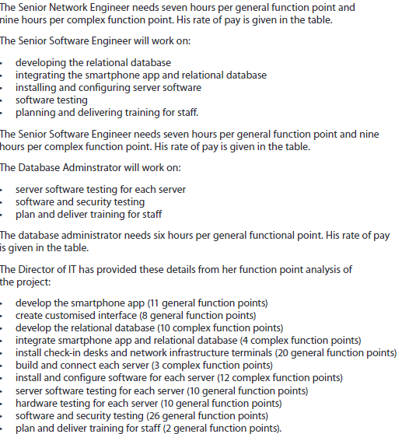



**Employee salary cost**

1. Develop the smart phone app = 11 general points (2)

Junior Software Engineer = 9 hours per general point

11 general function points x 9 = 99

99/ 7.5 = 13.2 days

99 x £20 = £1980

1. create customized interface = 8 general points (2)

Junior Software Engineers = 9 hours per general point

general function points x 9 = 72

72/ 7.5 = 9.6 days

72 x £20= £1440

1. develop the relational database = 10 complex points (4)

Senior Software Engineer = 9 hours per complex point

10 complex function points x 9 = 90

90 / 7.5 = 12 days

90 x £27 = £2430

1. integrate smartphone app and relational database = 4 complex points (4)

Senior Software Engineer = 9 hours per complex point

4 complex function points x 9 = 36

36/ 7.5 = 4.8 days

36 x £27= £972

1. Install check-in desks and network infrastructure terminals = 20 general points (4)

Senior Software Engineer = 7 hours per complex point

20 general function points x 7 = 240

40/ 7.5 = 5.3 days

40x £27= £1080

1. build and connect each server = 3 complex function points

Senior Network Engineer = 9 hours per complex point

3 complex function points x 9 = 27

27/ 7.5 = 3.6 days

27 x £27= £729

1. install and configure software for each server = 12 complex function points

Senior Software Engineer = 9 hours per complex point

12 complex function points x 9 = 108

108 / 7.5 = 14.4 days

108 x £27= £2916

1. server software testing for each server = 10 general function points

Database Administrator = 6 hours per complex point

10 complex function points x 6 = 60

60 / 7.5 = 8 days

60 x £22 = £ 1320

1. hardware testing for each server = 10 general function points

Senior Network Engineer = 7 hours per complex point

10 complex function points x 7 = 70

70 / 7.5 = 9.3 days

70x £27 = £ 1890

1. software and security testing = 26 general function points

Database Administrator = 6 hours per general point

26 complex function points x 6= 156

156 / 7.5 = 20.8 days

156 x £22 = £ 3432

1. plan and deliver training for staff = 2 general function points

Database Administrator = 6 hours per complex point

2 complex function points x 6= 13

12 / 7.5 = 1.6 days

1 x £27 = £ 378

12 x £22 = £264

**Total salary for employees = 1980 + 1440 + 2430 + 972 + 1080 + 729 + 2916 + 1320 + 1890 + 3432 + 264 = 18,507**

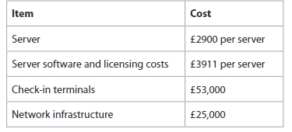

**Total for materials and labour = 2900 + 3911+53000+25000 = 84,771**